HAWB 15110

* Has single AirCosts + MAWB
* Sub-selection grid is not shown for single MAWB

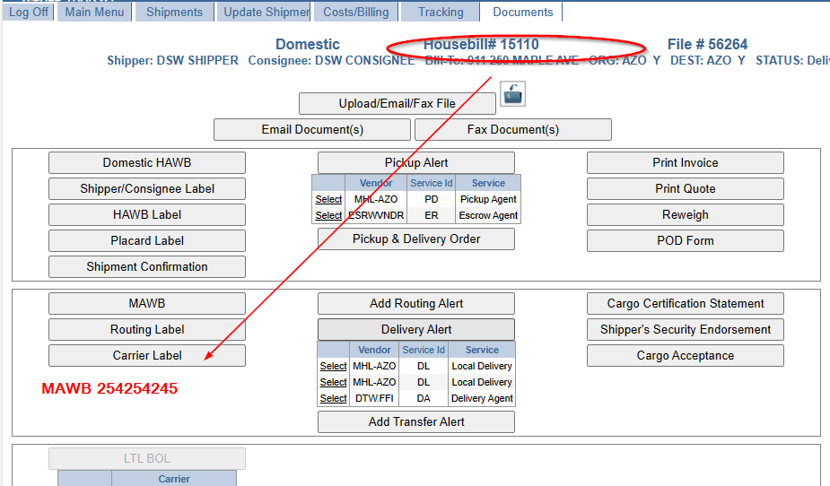

HAWB 13376

* Has multiple AirCosts + MAWB
* Sub-select grid is shown

