Yes, we tested this morning with Housebill # 7593883 / Shipment # 5345883 and it’s a pass!

Can the fix be promoted to prod on its own or will it need to be part of the next release?

Please let us know.

*Documented the steps during our testing session for historical purposes.*

1. After booking/sending the alert the EDI Alert column status changed to ‘S’ / 204 submitted.

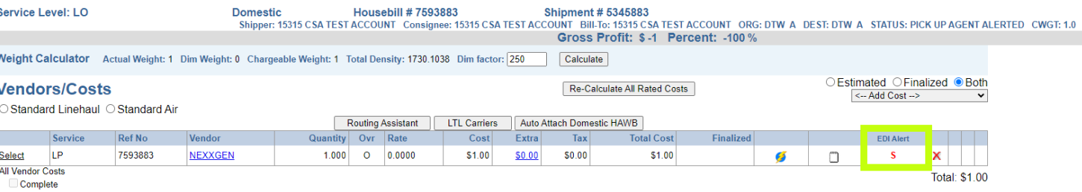

1. After the job was ran the EDI Alert column status changed to ‘B’ / 204 Booked.

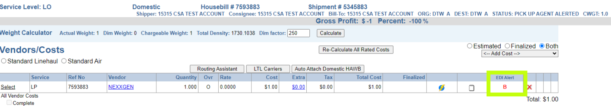

1. Inserted a 997 followed by a 990–– *acceptance message* and the EDI Alert column status changed to ‘C’ / 204 Accepted.

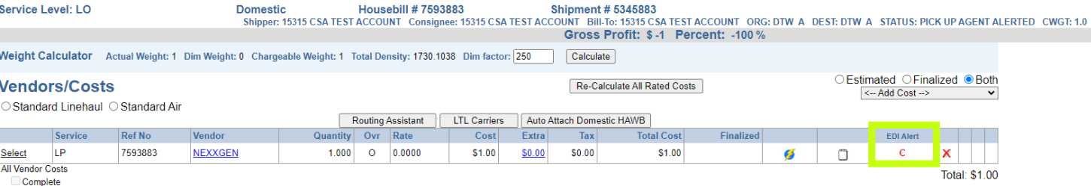

1. Added a new cost line for the same vendor under LD and tendered. Inserted a 990–– *rejection message* and the EDI Alert column status changed to ‘R’ / 204 Rejected/Decline.

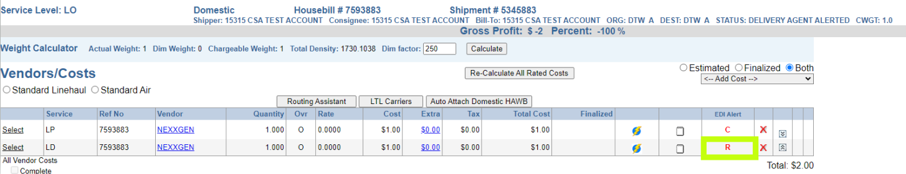

NOTE:

*We tried inserting a rejection message after an acceptance, but it didn't apply.*

*Similarly, we attempted to insert an acceptance message after a rejection, but it didn't apply either.*

*This means that vendors will need to contact us via email or phone if they accidentally accept or reject a tender.*