We tested this just now using [HAWB#7593882](https://wttest.omnilogistics.com/Worldtrak/Main/International/Costs.aspx?OrderNo=5345671&QS=S&QuickAir=&QuickLinehaul=) and the EDI alert column was not updated through our test.

Please review and let us know once this is ready for testing again.

[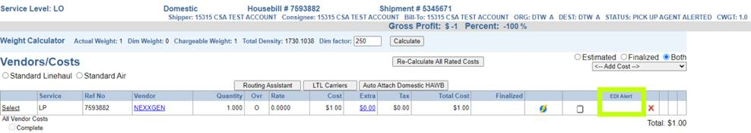](https://wttest.omnilogistics.com/Worldtrak/Main/International/Costs.aspx?OrderNo=5345671&QS=S&QuickAir=&QuickLinehaul=)

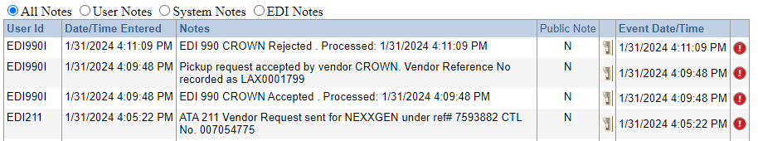

Just for reference, these were the values we were expecting to see:

S – 204/211 has been submitted/queued

B – 204/211 has been booked (the edi transaction has been sent)

C – 204/211 has been accepted by the vendor

R – 204/211 has been rejected by the vendor