There are 2 issues with the routing label:

**1) Deliver By field**

When there is a time window entered in the "Scheduled Delivery" field, World-Trak is pulling the start time of the window and not the close time.

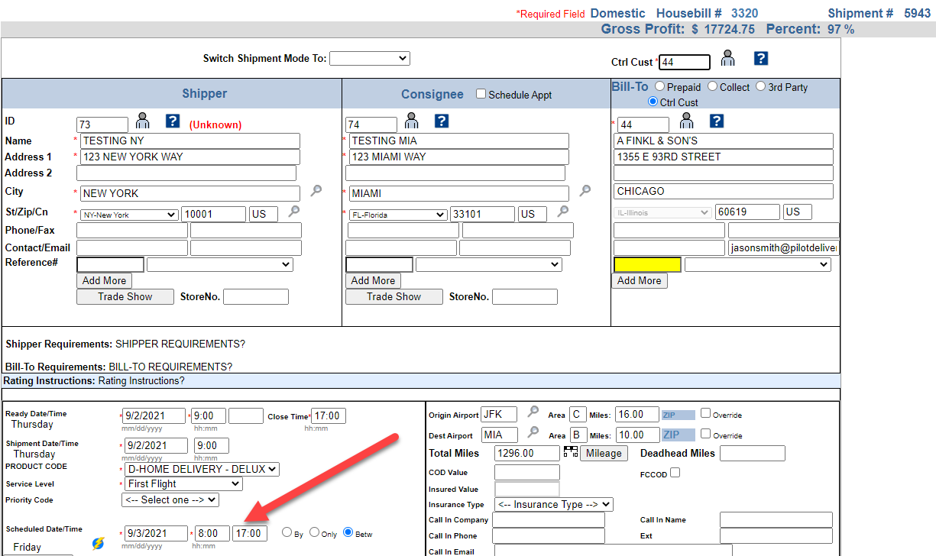

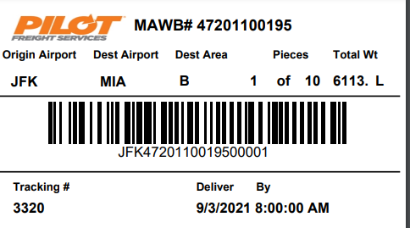

**2) Agent field**

When viewing the routing label from the Consol, World-Trak is pulling the Consol delivery agent and not the HAWB delivery agent

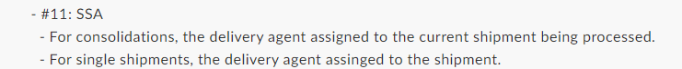

**Shipment Level Routing Label**

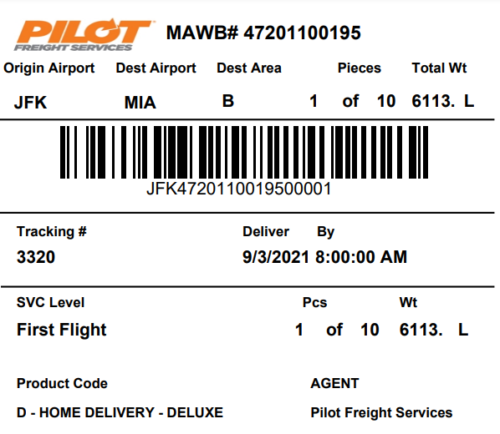

**Consol Level Routing Label**

