We noticed some issues with the Routing Label during a test of Consol #250:

-1) The top of the label is supposed to show the combined pieces and weight of all the shipments within the consol, but it only shows the individual shipment level details.

- 2) Pay Type is supposed to be removed.

(Removed from Both Shipment Level and Consolidation level)

-3) The bottom tracking number (ORD-45648914) is pulling from the Consolidation Ref # field but it should just be pulling the Dest airport code followed by the linehaul carrier prefix.

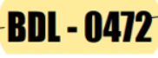

-4) The top MAWB # is also pulling from the Consolidation Ref # field but it's supposed to contain the line haul carriers prefix in front of the Auto-assigned Pro # field.

- 5) The "Agent" field in the label is showing the Agent # but we need it to show the Agent Name.

- 6)When printing the Routing Label from the Domestic Shipment Board, the MAWB information does not show up.

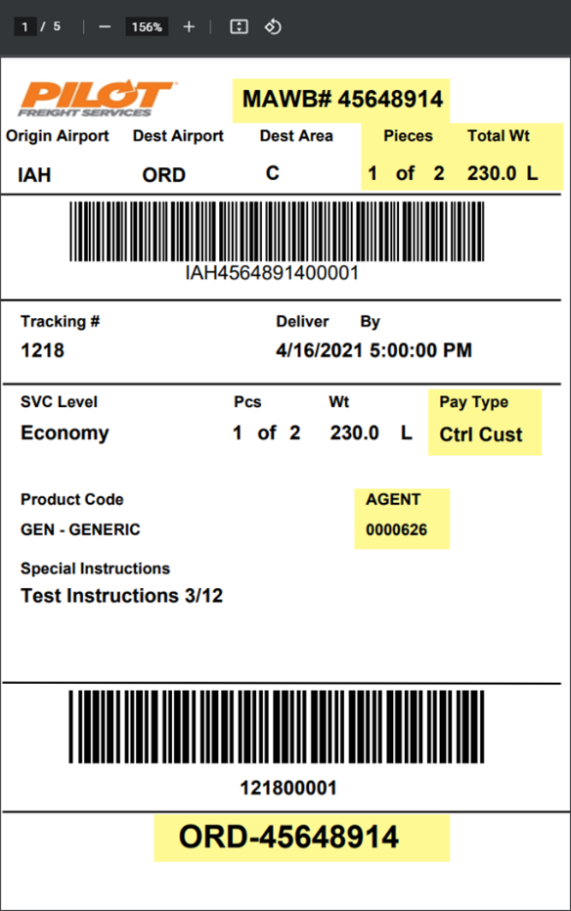

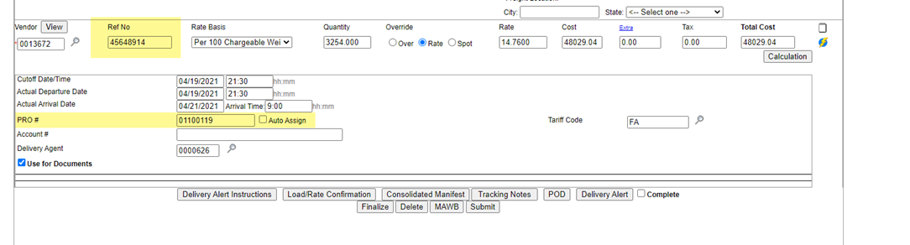

*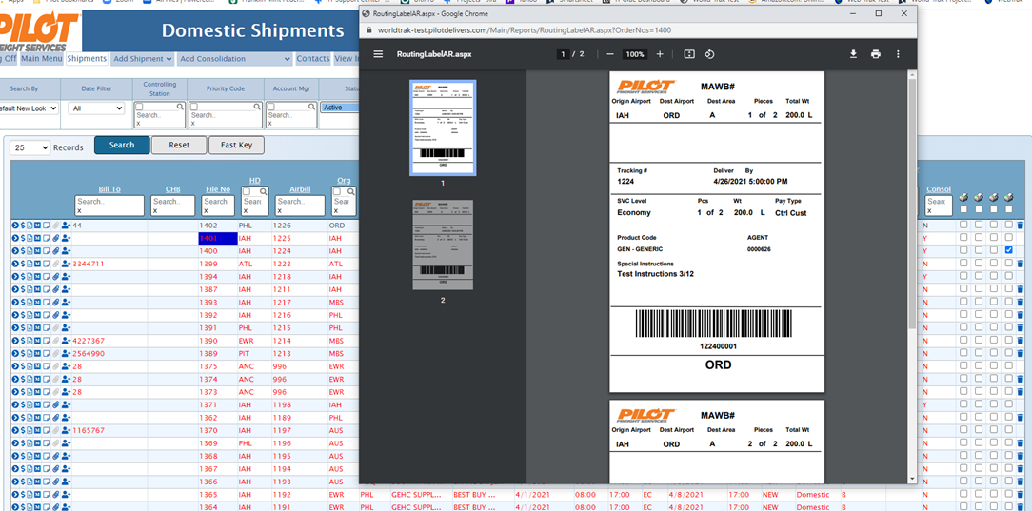*

Testcases from 162 for the above 5 fixes

1) Consol : 11367 Vendor : 247-MCO No vendor Prefix assigned in the VendorMaster-Additional Info.

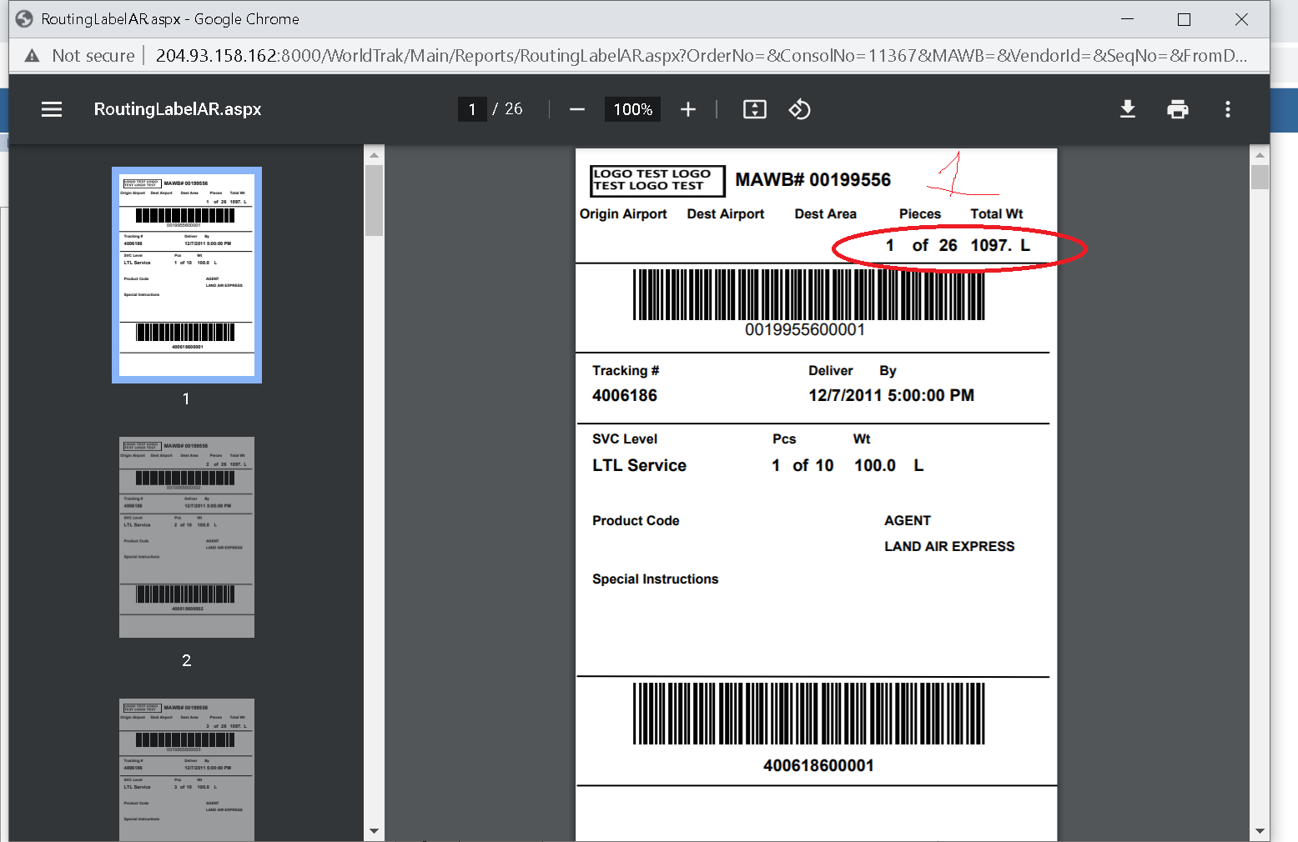

2) Shipment HAWB : 7119

