1. Product Code Description is wrapping. Reduce the font for this and the 'SSA' area.  
     
   2. Show the product code and the description. Example:  
   XXX - TEST PRODUCT CODE DESC  
     
   3. SSA is showing the salesperson. It should be showing the delivery agent vendor ID from the shipment/consol  
     
   4. Change the description of 'SSA' to 'AGENT'  
     
   5. The Barcode at the top of the label and the number underneath it need to be hidden if no MAWB# filled out for the shipment/consol. tbl_aircost - MAWB  
     
   6. You are showing delivery instructions instead of special instructions. Please fix.  
     
   7. If you aren't already doing this, you need to show the waybill prefix (vendor master - additional info for LH or Air Carrier) after the destination airport at the bottom of the label.  
     
   8. Remove 'Party Type' from the form.  
     
   9. The label is NOT sized correctly. It should be just like every other form. Please fix.

Currently the size is 4X6 like other form. Can you please give on test case if possible.  
  
10. Consol# 200 -  
  
a. The MAWB # isn't appearing on the label or under the Master bill barcode.  
b. The carrier code isn't showing next to the shipment level barcode.  
c. And when using the CHB, the tracking # field is showing correctly, but the barcode still shows the HAWB number.

Consol : 11367 Label : 26 ( Last Label)

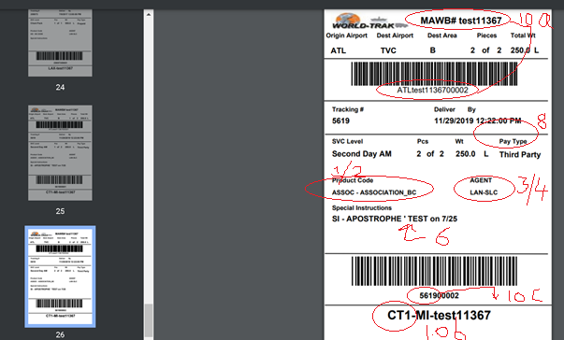

Shipment : OrderNo : 42747 Carrier : FORAIR MAWB : 0019955667756

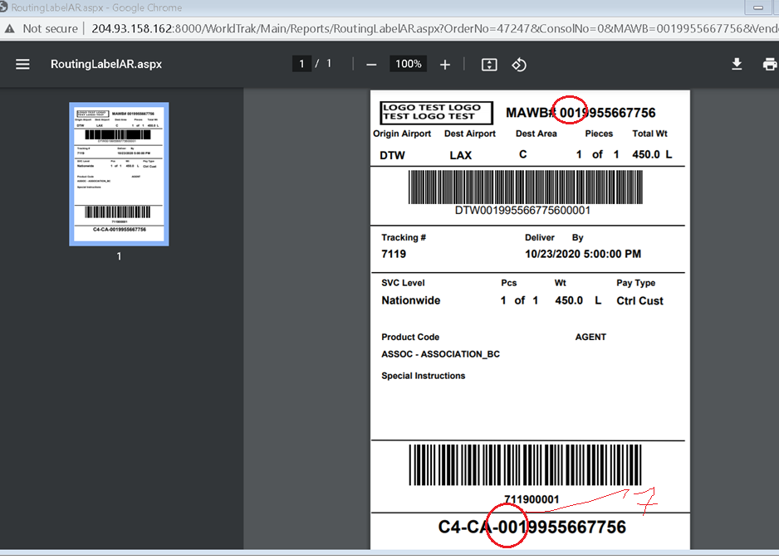

Shipment : OrderNo : 42747 Carrier : VENTURE MAWB : Null

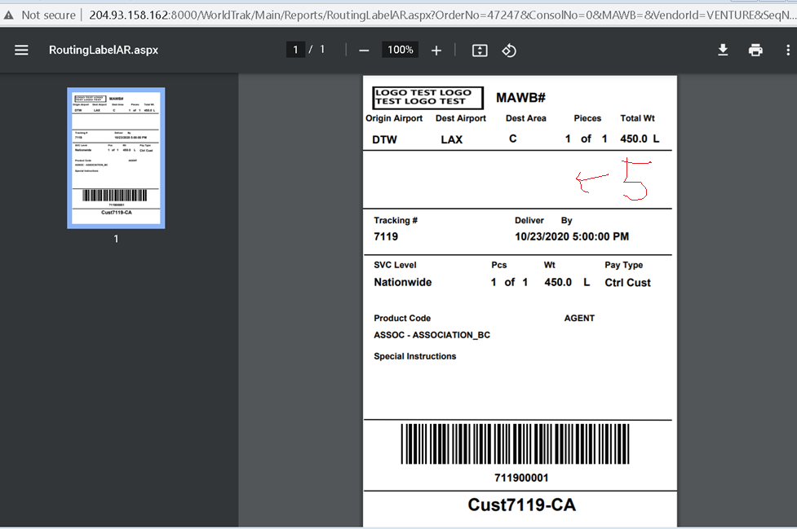

1. ok.  
     
   2. ok.  
     
   3. ok.  
     
   4. HAWB 7119 - I added a delivery agent to the shipment. The delivery agent isn't showing on the label. Why? Fixed this and it shows ‘**247-MCIO**’ as below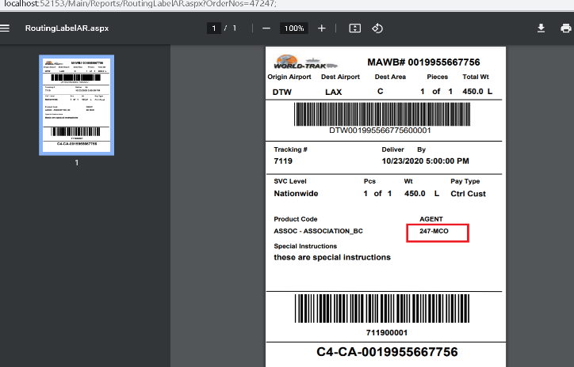

5. ok.  
  
6. ok

7. If you aren't already doing this, you need to show the waybill prefix (vendor master - additional info for LH or Air Carrier) after the destination airport at the bottom of the label.  
  
HAWB 7199 - I picked the FORAIR carrier and generated the label. The prefix is shows 001, which I know isn't correct. FORAIR is set to '472'. I believe it is picking it from AA-DOM.

No Brian, Currently the MAWB saved in the tbl_AirCost for Carrier ‘FORAIR’ is 0019955667756. I just pick this MAWB and Show it in the Label.

I initially thought that when we update the WayBill prefix in Vendor Masters-Additional info table , the MAWB is recalculated on Submit with the prefix 472. But that doesn’t happen when I tried.

With the above requirement do you want mw to append ‘472’ to this MAWB and show it as 4720019955667756 ? for LH and AA carriers after the destination airport at the bottom of the label?

Also - What are you doing when there is more than 1 carrier on the shipment and you produce the label from the shipment board? Just picking the first carrier you see?

We pick the Carrier (FORAIR) with IsDefault set to ‘Y’ as seen in below snapshot. (HAWB 7199)

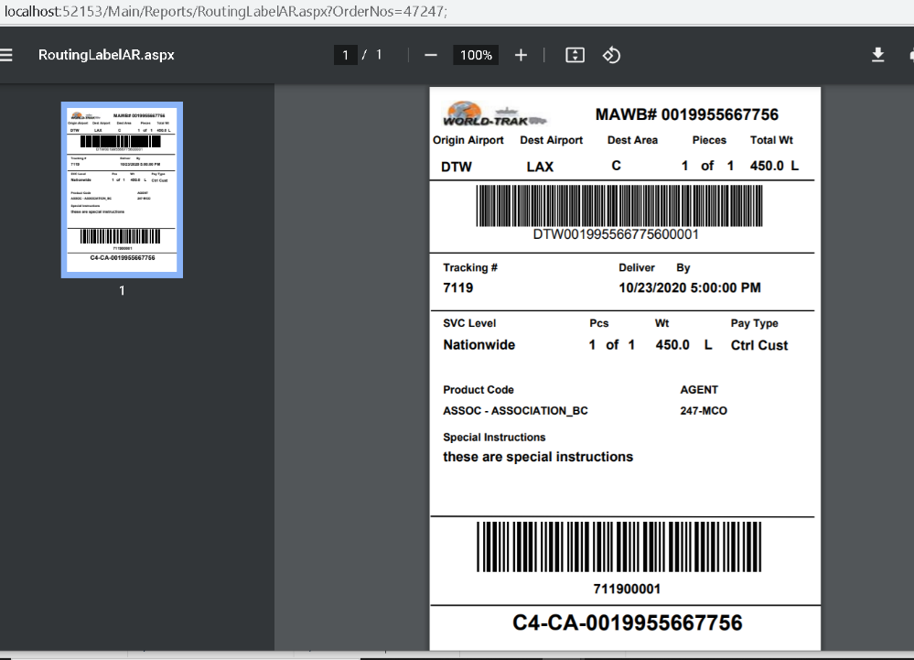  
  
8. ok.  
  
9. Sorry...I meant to type the LOGO. Like this:  
  
The logo is NOT sized correctly. It should be just like every other form. Please fix. (Fixed)  
  
10. Consol# 11367 - on 162  
  
a. ok  
b. The carrier code isn't showing next to the shipment level barcode.

Brian, Are you taking about 14 or 15? I do not see any place in the requirement which states carrier code.(Please see below with the snapshot and the requirement for 14 and 15-16). Currently we show - Customer Code + "-" + the Consignee's State + "-" + the MAWB (#1) prefix (3 chars). For (15-16) if we get hit in the new table for the corresponding Bill-To#, Consignee#, and VendorId

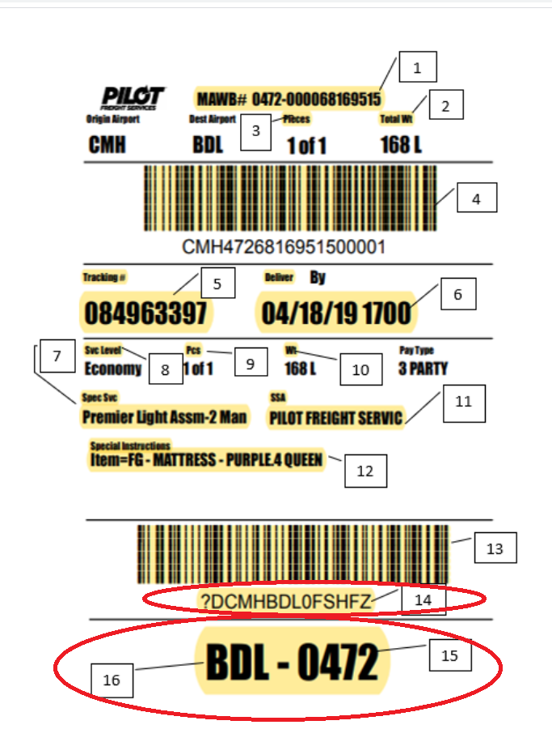

- #13/#14: Tracking Barcode (Code 39)

- Tracking# (#5) + piece count (#9) (5 digits with leading 0’s)

- #15/#16: Destination Airport

- First, query the new table by Bill-To#, Consignee#, and VendorId of the shipment, or the current shipment being processed for consolidations.

- If you get a hit:

- Customer Code + "-" + the Consignee's State + "-" + the MAWB (#1) prefix (3 chars).

- If you don't get a hit:

- For consolidations, the destination airport of the current shipment being processed + "-" + the MAWB (#1) prefix (3 chars).

- For single shipments, the destination airport of the shipment + "-" + the MAWB (#1) prefix (3 chars).